This document is going to take a comparison at some of the most popular SMS and WhatsApp API service providers that we intend to use in the development of the notification service that is a module of the server application that we are developing.

We will require SMSs mainly for the mobile application since it will not print a receipt. We have looked into several options and believe the best option to consider is **Nexmo** (<https://www.nexmo.com/>) for the following reasons:

* **We looked at opportunities to send messages internationally**. Once we have the mobile application, there is no reason this system cannot be accessed from any country.  We believe it would be wise to have multi country SMS option from the beginning.
  + It is possible for example to start vending in South Africa by just enabling another server with a new currency then buying pin based vouchers initially.
  + It is also possible for me to use your integration to send SMSs for my website ([https://streetsmart.co.zw](https://streetsmart.co.zw/)). This for example provides you an opportunity to resell SMSs to other companies, whoever is interested, anywhere in the world, such as me.
* **We looked at pricing.**Based on several providers that send SMSs to Ghana (Twilio, Nexmo, Clickatelle, Plivo and others) **Nexmo has almost the best price.**Based on this website <https://jungleworks.com/sms-voice-api-twilio-vs-nexmo-plivo-sinch-mobile-app-guide/> Plivo may be able to offer a slightly better price, but the cost saving is roughly US$0.0014 per SMS, less than  1 US cent per message, but the features for future growth will limit us.
* **We looked at features.**Nexmo offers the most number of options. SMS, WhatsApp, Facebook & Viber messages. We believe we will need WhatsApp messaging in the future.
  + There is an option to immediately start selling vouchers using WhatsApp, without even an Android application. This can also immediately expand your reach.

The below table is a summary of the research, followed by the complete data:

|  |  |  |  |
| --- | --- | --- | --- |
|  | Twilio | Nexmo | Clickatell |
|  |  |  |  |
| Countries | All Countries | All Countries | All Countries |
| Estimate SMS Price (per message) | **US$0.0483** | **US$0.0468** | **US$0.12697** |
| WhatsApp Messaging | Yes (Beta)    **Roughly $0.0626/msg**  - Branded message option.  - Alerts and Notifications.  - Customer Support.  - User Verification & 2 Factor Auth | Yes    **Roughly $0.0576/msg** | No    **Roughly $US0.0125/msg**  - Monthly price of US$125  - solution captures delivery status, replies, and SMS opt-out |
| VOIP | Yes - Numbers in 30+ countries  - Anonymous real-time conversations | Yes | Yes |
| Facebook Messenger | No | Yes    US$0.0011 per msg | No |
| Viber Messaging | No | Yes | No |
| Additional Info | - Through Twilio Autopilot one can build AI-powered conversational bots to serve customers across web and mobile chat, SMS, and WhatsApp    - Provides integrations code snippets for the main programming languages like C#, Java, ruby, python and node.js.    - Allows you to send branded SMSs  - Volume Discounts    - Receive larger discounts with monthly committed volume |  | - With convenient two-factor authentication, users can log in without having to memorize passwords or use an extra app.    - With text message marketing, you can inspire your customers with reactivation campaigns and event-based, region-specific offers. |

**FLASH MEDIA**

This is a South African company that is mostly operational in SA and Zimbabwe.

* Their SA Partners and Clients includes MTN, Cell C and Vodacom, Telkom Mobile
* No mentioning of WhatsApp API
* They also provide USSD services

SMS

- Baseline throughput of 160 transactions per second  
- SMS pricing includes premium rated and bulk.

SMS messaging

- with immediate reply channel with a built-in reply-to channel.

- SMS messages are charged on a per message basis by the mobile network operators.

- You can send bulk SMS messages, via the TMS3 web interface, a HTTP request, SOAP web services or e-mail.

- Premium rated SMS messages cost more than standard SMS messages.

- TMS provides an implementation of Outlook Mobile Services, allowing you to send bulk or individual SMS messages directly from Microsoft Outlook - no extra installation necessary!

- TMS provides a downloadable extension for the popular open-source Mozilla Thunderbird e-mail client that enables Thunderbird to send individual bulk SMSs directly to contacts in your address book.

**TWILIO**

This is an international company that provides services all over the world.

They have an API for WhatsApp (Which is in Beta version) that provides the following services:

* 1. Allows you to send branded messages.
  2. Alerts and Notifications.
  3. Customer Support.
  4. User Verification and 2 Factor Authentication.

SMS Service

Their SMS service provides the following:  
- Send and receive text messages globally with the API that is being used by over a million developers.  
  
- Their website provides integrations code snippets for the main programming languages like C#, Java, ruby, python and node.js.  
  
- Scale conversations to support groups on SMS, WhatsApp, and chat.

- Through Twilio Autopilot one can build AI-powered conversational bots to serve customers across web and mobile chat, SMS, and WhatsApp

- With phone numbers available in over 30 countries

- Twilio Authy: Two-factor authentication

- Twilio Verify: Phone verification to prevent fraud

- Twilio Proxy: Anonymous real-time conversations (Hides the ID of the sender)

RCS Business Messaging

- allows you to send branded SMSs

Flexible SMS pricing options

- Starting at $0.0005 per message, select the pricing option that’s right for you.

* Pay-as-you-go

Pay only for what you use, when you use it. No contracts. No capacity planning.

* Volume discounts

Automatically receive discount pricing once your application reaches volume scale.

* Committed-use discounts

Receive larger discounts with monthly committed volume.

* Committed-use discounts

Receive larger discounts with monthly committed volume.

SMS Pricing for SA

Price of sending SMS in SA $ 0.0270

Price of receive SMS in SA $ 0.0075

**CLICKATELL**

This is an international company that provides WhatsApp, VOIP and SMS services.

WhatsApp

* Travel
* Retail
* Banking
* Telecommunications

WhatsApp Pricing

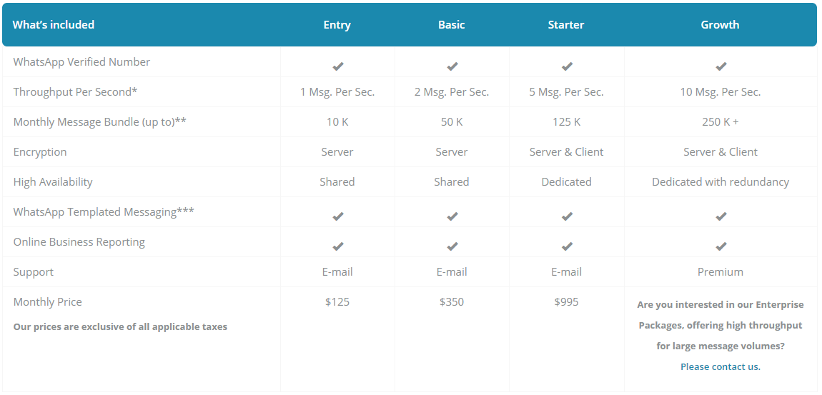

- Allows importing of contacts using CSV files

The solution captures

* delivery status,
* replies, and
* SMS opt-out

Reach

* Send messages to any country

Provides The following

* Reminders: Set, confirm, and remind customers of appointments and reservations
* Notifications/Alerts: Inform customers or employees of issues that need immediate attention
* Surveys: Engage customers and gather their opinions with 2-way messaging
* Events: Engage event attendees with messages, such as welcomes, venue information and event alerts
* Message both individual contacts and groups
* Allows use of short codes to send SMSs
* Promotions: Send customers coupon codes and offers related to their favorite products

SMS Pricing

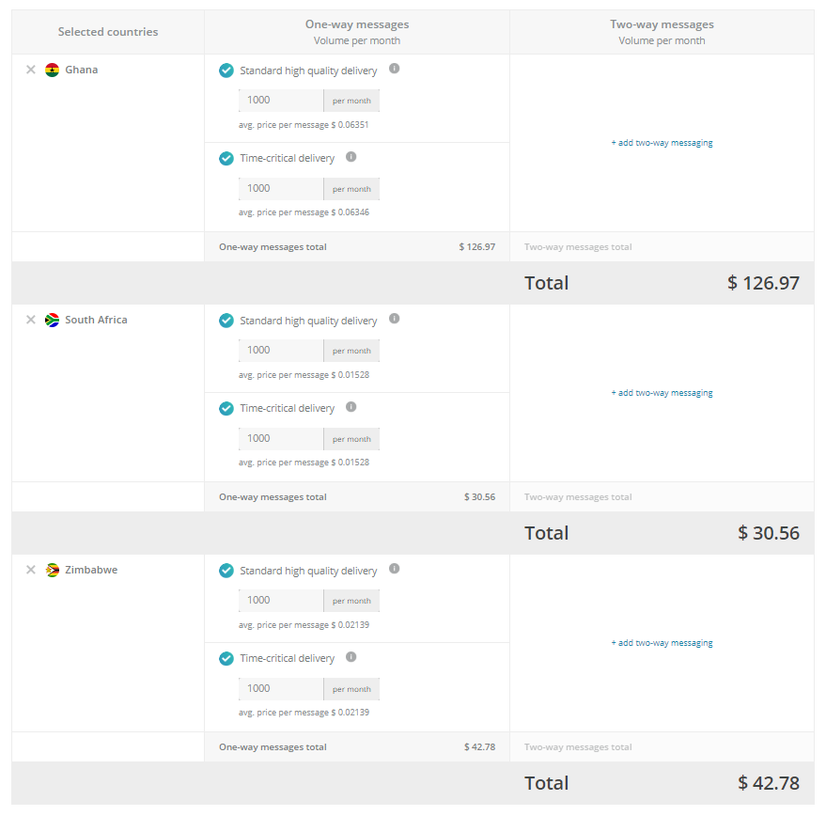

**NEXMO**

This is an international company that provides WhatsApp and SMS services.

SMS service

Provides private SMS communication: With private SMS communication, your users can seamlessly and safely book appointments, confirm deliveries, and more.  
Send the right message at the right time.

Use notifications to send timely, well-targeted SMS messages that surprise and delight your users. (Think booking confirmations and reminders.)  
Authenticate with ease.

With convenient two-factor authentication, users can log in without having to memorize passwords or use an extra app.  
Get noticed.

With text message marketing, you can inspire your customers with reactivation campaigns and event-based, region-specific offers.

SMS Pricing

GHANA

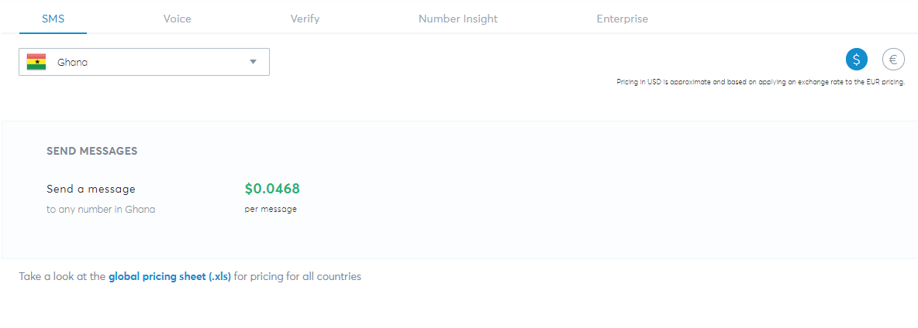

South Africa

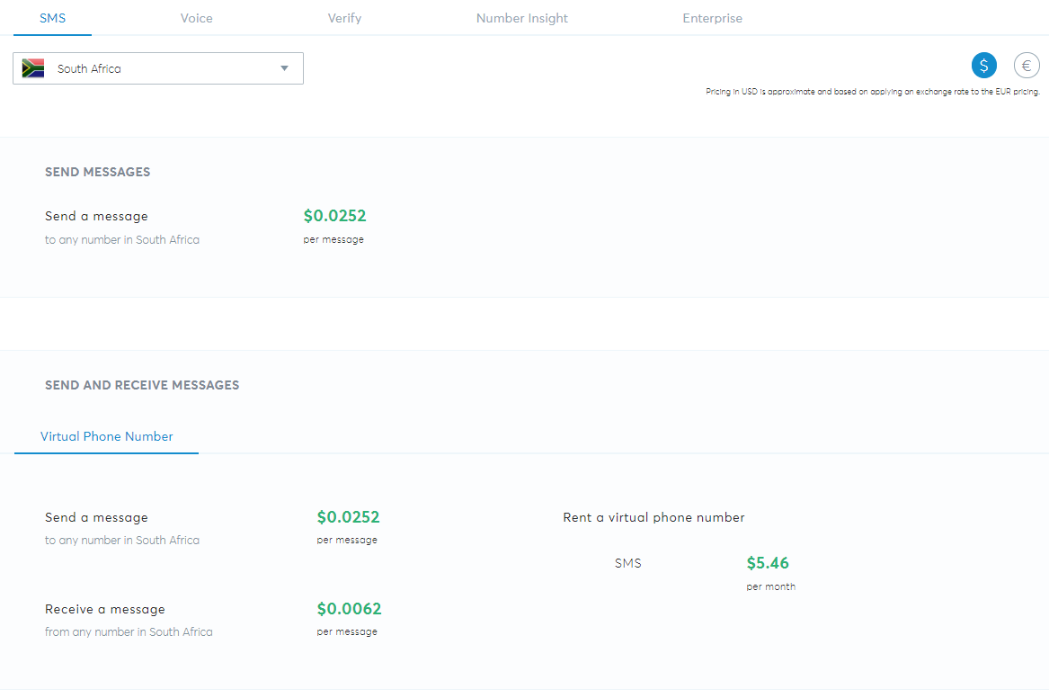

Zimbabwe

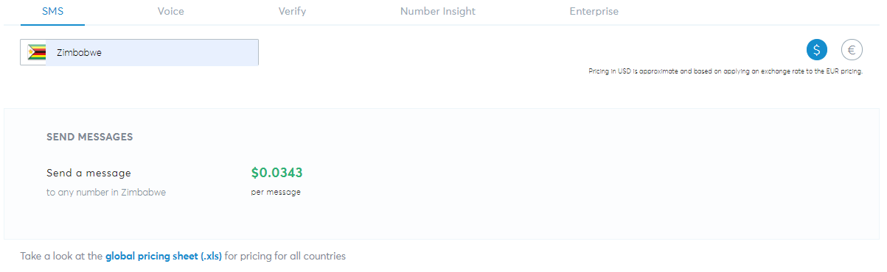

WhatsApp service Pricing

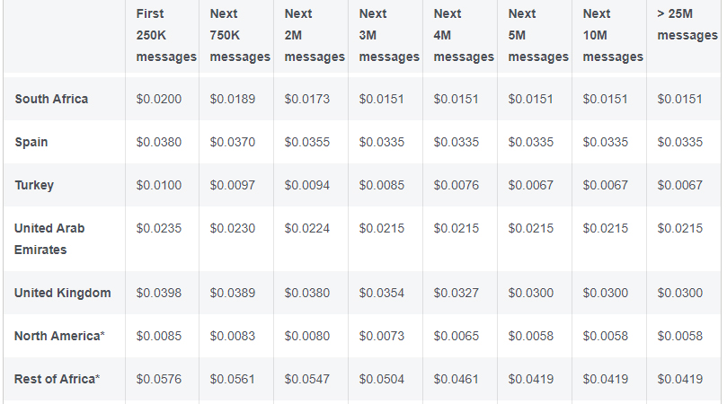

Facebook Messenger

Enables one to expand their interactions with their customers. Send them tickets, QR codes, and images, make a phone call or engage them with video -- whatever the method, Facebook Messenger provides you with the avenue to drive a more engaging customer experience.

Facebook Pricing

